**GEOG 531**

**Tutorial 2: Basic Programs**

This tutorial will introduce the concepts of creating form and writing code. We will create an application to take a sales amount from the user and calculate the commission to be paid on that sale. The application will look something like this:

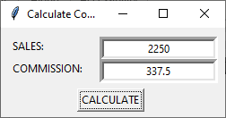

**Start-up**

1. Start Visual Studio (VS) Code. Create a new Python file (the menu *File > New File*). Save (*Ctrl+S*) it with the name **Tutoril2.py** inside your working folder.

**Create the form and controls**

1. Create a root Tkinter window FrmCalcCommission with the title Calculate Commission and dimensions of 200 by 100 pixels similar as you have done that in Tutorial 1. Do not forget to enclose your script with .mainloop() function. Run the window to test it and then close it.

import tkinter as tk

FrmCalcCommission = tk.Tk()

FrmCalcCommission.title("Calculate Commission")

FrmCalcCommission.geometry("250x100")

FrmCalcCommission.mainloop()

1. Place two *Label*son the root window as below and test your FrmCalcCommission.

lblSales = tk.Label(FrmCalcCommission, text = "SALES:")

lblSales.place(x=10, y=10)

lblCommission = tk.Label(FrmCalcCommission, text = "COMMISSION:")

lblCommission.place(x=10, y=35)

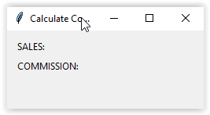

1. Place two new *Entry* textboxes on your FrmCalcCommission. Run the script. Textboxes should be to the right of your labels and oriented as below.

txtSales = tk.Entry(FrmCalcCommission, bd=5, justify="center")

txtSales.place(x=110, y=10)

txtCommission = tk.Entry(FrmCalcCommission, bd=5, justify="center")

txtCommission.place(x=110, y=35)

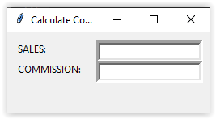

1. Add the btnCalculatebutton widget on your form as below and test the FrmCalcCommission. So far, the calculate_Click() function does not include the code and will be not functioning.

def calculate_Click():

    pass

btnCalculate = tk.Button(FrmCalcCommission, text="CALCULATE", command=calculate_Click)

btnCalculate .place(x=85, y=68)

*Code explanations:* function definitions cannot be empty, but if you for some reason have a function definition with no content, put in the pass statement to avoid getting an error.

1. Save your work by clicking *File* > *Save* or *Ctrl+S*.

So far, we built the FrmCalcCommission window, added controls and set some their properties.

It is common in Windows applications for a user to be able to move the *focus* from one control to another by pressing the TAB key. The order in which the controls get focus by tabbing is determined by the focus property.

1. Set the focus property to be on txtSales. Enter the following code before FrmCalcCommission.mainloop():

txtSales.focus()

**Writing Code**

1. Within the def calculate_Click(): function, comment the pass statement with # in front of it (or use *Ctrl+/* to comment a line or multiple selected lines) and insert the code to calculate sales commission as follows:

def calculate_Click():

    # pass

    fltCommission = float(txtSales.get()) * 0.15

    txtCommission.delete(0, tk.END)

    txtCommission.insert(0, fltCommission)

*Code explanations:* The main functionality of def calculate_Click() function is to get an user’s entered value from the txtSales textbox, calculate a commission, clean the txtCommission textbox and then insert the value of commission into the cleaned txtCommission textbox.

First, we get a text from txtSales.get() textbox, convert it into floating number by using the Python standard function float(), and multiply by 0.15 to get 15%. The float() build-in Python function converts the specified value into a floating-point number. The method .get() is used to fetch the current entry text from the textbox.

In additional to the get() method, the widget Entry provides the methods delete and insert which can be used to set Entry’s text to a new value. First, you might need to remove any former, old text from Entry with delete which needs the positions where to start and end the deletion. Since we want to remove the full old text, we start at 0 and end at wherever the end currently is. We can access that value via tk.END. Afterwards the Entry is emptied, and we can insert value of fltCommission at position 0 of the textbox.

**Running the Program**

1. Click the *Run* button . The *COMMISSION* box should show you 15% of any number you placed in the *SALES* box, after clicking on the *CALCULATE* button. Test your script.

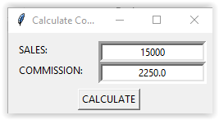

1. Fix any errors which occur if so.

Note that this program will give an error (see the *Terminal* window) if you try to enter a text string in the *SALES* textbox. This is because Python cannot perform arithmetic (i.e., calculate 15%) with text. You may wish to try this, just to see how it works. We will code verifications of entries in the following tutorials.

1. Save your script and exit VS Code.